**ACKNOWLEDGEMENT**

We would like to express our special thanks of gratitude to our teacher MR. SUNIL KUMAR T (PGT COMPUTER SCIENCE) as well as our principal MR. Ganesh Suryakant Indrale sir who gave us the golden opportunity to do this wonderful project on the topic Hotel Management System, which also helped us in doing a lot of Research and we came to know about so many new things. We also thank the staff of Hotel Deepa Comforts, Kodialbail Road Mangaluru-575003 who guided and helped us with this project. Secondly, we would also like to thank our parents and friends who helped us a lot in finalizing this project within the limited time frame.

**Principal Teacher In-Charge**

**Date: Examiner’s Sign**

**HARDWARE AND SOFTWARE REQUIREMENTS**

**HARDWARE REQUIRED**

1. A processing system capable of running Windows Operating systems.

2. A minimum 64 MB RAM (desirable: 128 MB) at server.

3. Minimum 60 MB free space for files.

4. A CD ROM drive.

**SOFTWARE REQUIRED**

1. Windows 8 or above.

2. Wamp (32 or 64 bit).

3. Microsoft Word/ Microsoft PowerPoint.

**OBJECTIVES OF THE PROJECT**

Over the years, we have developed in the field of technology and therefore our ways of storing information has changed. This project aims the goal of providing an effective method of data management, keeping our focus on the hotel management system.

A computer-based management system to handle all the primary information to calculate the monthly statements. A separate database is maintained to handle the details required for correct and accurate calculations and output.

Introduces effectiveness in the various activities of information updation, maintenance and search operations.

The information maintained can be accessed by authorized users only ensuring high security.

Easy updation enables to maintain up-to-date records.

**INTRODUCTION TO THE PROJECT HOTEL MANAGEMENT SYSTEM**

The Hotel Management system is to generalize and simplify the monthly or day to day activities of Hotel like Room activities, check in of New Customer, check out of the customer, assigning a room according to customer requirement, and finally compute the bill etc. which must be performed repeatedly on regular basis. To provide efficient, fast, reliable and user-friendly system is the basic motto behind this exercise. And show the Hotel room facilities, Book room. The main aim of the entire activity is to automate the process of day to day activities of Hotel like room activities, admission of a new customer, assign a room according to customer's demand, checkout of a computer and releasing the room and finally compute the bill etc.

**THE LIMITATIONS OF THE PROPOSED SYSTEM**

Our proposed system was Axis Rooms Channel

Manager' which was being used in Hotel Deepa Comforts.

After talking to the hotel staff about the software and performing a system study, we have concluded that there are certain drawbacks:

1. Inability to store large amount of information with modifications.

2. Less security of the details of the login facilities of the individual hotel staff.

With our system, we would try to remove these drawbacks and limitations and make the program of hotel management work effectively.

**PURPOSE OF OUR PROJECT**

The main purpose of our exercise is to perform each

employee activity in computerized way rather than

manually which is time consuming.

The entire activity is to aim the process of day to

day activities of hotel like:

1. Room activities very safely.

2. Design a room according to customer's check-out of computer.

3. Release the room and finally computer the bill in short time.

**Admin Module**

In this module admin controls the whole project. This contains sub modules such as Admin login module, employee module, customer module and room status module. Administrator has an authority to handle the front end also the back end process of the system.

**User Module**

In this module user can view the information of the website and he/she can also register for lodging in advance with fully advance payment. User has to login into the system for the registration. User can

view only the front end of the website. This contains sub modules like information module, login module, contact module, registration module and reservation module.

**ROOM BOOKING**

This page takes the customer to the login

page for reservation. If Customer is a new

user the he must register at first and then he

can login with his user name and password.

After login several procedures like, entering

the details in reservation page for booking is

to be done.

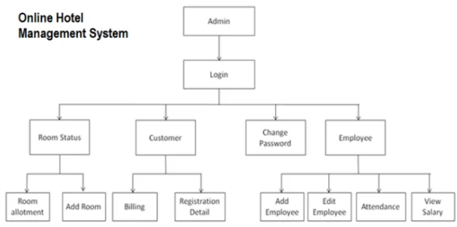

**DEPARTMENTS OF A HOTEL**

1. Accounting Department.

2. Housekeeping Department.

3. Engineering Department.

4. Front Office Department.

5. Human Resource Department.

6. Security department.

7. Food and Beverage Department.

**MAIN OBJECTIVE IS TO AUTOMATE PROCESS OF DAILY ACTIVITIES LIKE:**

1. Room activities.

2 Addition of a new customer.

3. Assignment of room as per customer's demands.

4. Check out and releasing the room.

5. Computing bill.

6 Advanced online bookings.

7. Online cancellation.

8. List of regular customers and their activities.

**FEATURES**

Becomes easy to find the details about:

1. Availability of unoccupied rooms.

2. past customer record.

3. Easy to know the company balance.

4. Overall record of the customers.

5. Easy to know how much services taken by the customer.

Bill generation process will become easier.

Easy generation of various types of reports such as -

1. Service report.

2. Company reports.

3. Customer reports.

**EXISTING FEATURES**

"HOTEL MANAGEMENT SYSTEM" has been designed to computerize the following functions that are performed by the system:

1. Room detail function.

2. Opening a new room.

3. Modification to room assigned.

4. Check-in and check-out function.

5. Sign up of new customer.

6. Room assigned related to customer's need.

7. Statement of customer details.

8. Room details.

**INDIVIDUALL CUSTOMER REPORT**

**1. Registration Module**

**Inputs:-**

Date of Booking: (by the administrator)

Registration Number: (by the administrator)

First name: (by the customer)

Last name: (by the customer)

Citizenship: (by the customer)

National ID Card No.: (by the customer)

Gender: (by the customer)

Phone No.: (by the customer)

Address: (by the customer)

Email Account: (by the customer)

**Algorithm:-**

1. Input date of booking and registration number.

2. Input name of the customer and National ID Card Number.

3. Input Phone Number, address and Email ID.

4. Details of the customer is stored.

5. Displays successful prompt.

E.g.:

**HOTEL DEEPA COMFORTS**

**Date of booking**: 11/01/2020

**Registration Number**: MM1131

**First name**: Varun

**Last name**: Sharma

**Citizenship:** Indian

**National ID Card No**: IND19654

**Gender:** M

**Phone No.**: 9564523231

**Address**: Kunjathbail

**Email Account**: varunsha1951@gmail.com

**Date of booking**: 15/11/2018

**Registration Number**: LA1101

**First name**: Riya

**Last name**: Vardhan

**Citizenship:** Indian

**National ID Card No**: IND15691

**Gender:** F

**Phone No.** : 9880740893

**Address**: Surathkal

**Email Account**: riyavnitk@gmail.com

**Output:-** It immediately displays and stores the details of the customer.

**2. Room Selection Module**

**Inputs:-**

Number of people: (by the customer)

Number of rooms required: (by the customer)

Type of bed required (*single/double*): (by the customer)

Type of room required (*Suite/premium AC/premium non AC*): (by the customer)

Number of rooms available: (printed by the software)

The room made available for the package selected: (by the software)

National ID Card No: (by the customer)

Phone number: (by the customer)

Payment mode (*debit card/credit card/cash/other*): (by the customer)

**Algorithm:-**

1. Input no. of people and no. of rooms required.

2. Select the type of room.

3. Checks the availability of rooms and prints the appropriate message.

4. Select the payment mode.

5. Success prompt is displayed .

**Output:-**

This will generate the room type and room number as per the customer’s convenience. If any further problems are to be clarified personally, the phone number column is included. Moreover, the number of vacancies or ‘no vacancy’ will be printed while booking.

Eg:-

**HOTEL DEEPA COMFORTS**

**Number of people**: 3

**Number of rooms required**: 1

**Type of bed required (*single/double*)**: Double

**Type of room required (*suite/premium AC/premium non AC*)**: Premium Non AC

**Number of rooms available**: 5

You can proceed further to booking your room.

**National ID Card No**.: IN37465

**Phone number**: 9867548479

For further correspondence please call us on 011-3257804 for complete confirmation of payment and other details.

**Payment mode (*Debit card/Credit Card/Cash/Other*)**: Credit Card

You will be directed to another page for the payment . . .

**Thank you so much for choosing our services. Your room has been booked.**

**3. Accommodation Module**

**Inputs:-**

First name: (by administrator to retrieve information and further fill the details of the customer)

Last name: (by administrator to retrieve information and further fill the details of the customer)

National ID Card No.: (by administrator to retrieve information and further fill the details of the customer)

Room Category: (by the customer)

Room No.: (by the administrator based on the vacancies and convenience of the customer)

Accommodation charges: (by the administrator)

Receipt No.: (by the administrator)

Mode of payment: (by the customer)

Total charge: (by the administrator)

**Algorithm:-**

1. Input the customer name.

2. Select the type of room.

3. Receipt No. and total charge is calculated.

4. Select the mode of payment.

E.g.:

**HOTEL DEEPA COMFORTS**

**First name**: Vishnu

**Last name**: Santhosh

**National ID Card No.**: IND25847

**Room Category**: Premium AC

**Room No.**: 1106

**Accommodation charges**: Rs.3500

**Receipt No.**: 708904090

**Mode of payment**: Credit card

**Total charge**: Rs.5000

**First name**: Aditi

**Last name**: Naithani

**National ID Card No.** : IND71674

**Room Category**: Suite

**Room No.** : 1920

**Outputs:-**

It helps the customer choose their package and displays their payment details for further payment for their stay.

**4. Meals Module**

**Inputs:-**

Registration No.: (by the staff to retrieve the details of the customer and add the meal charges to their final bill)

Room No.: (by the customer)

Type of Meal (Breakfast/Lunch/Dinner):

(by the customer)

Charges of the current meal taken: (by the staff)

Receipt No.: (by the staff)

**Algorithm:-**

1. Input the registration number and room number.

2. Input the type of meal.

3. Charge of the current meal and Receipt number is calculated.

4. Success prompt is displayed.

E.g.:

**HOTEL DEEPA COMFORTS**

**Registration No.:** KL84579

**Room No.:** 108

**Type of Meal (Breakfast/Lunch/Dinner**): Lunch

**Charges of the current meal taken**: Rs.1300

**Receipt No.**: 1038475910

Registration No. : LA1901

Room No. : 1560

Type of Meal (Breakfast/Lunch/Dinner): Lunch

**Charges of the current meal taken**: Rs.2700

**Outputs:-**

The bill for the current meal will be immediately prepared.

**5. Staff or Employee Details Module**

**Inputs:-**

Staff No.: (by the administrator)

Full name of the Staff: (by the staff)

Mobile No. of the staff: (by the staff)

Facility provided: (by the staff)

National ID Card No.: (by the staff)

Address of the staff: (by the staff)

Email ID: (by the staff)

Employee account No.: (by the staff)

Salary: (by the administrator)

**Algorithm:-**

1. Input the staff details such as name, mobile number.

2. Input the faculty provided by the staff.

3. Validate the Email ID and Account number of the staff.

4. Salary of the staff is being displayed.

**Output:-**

This immediately stores and displays the information of individual staff member. This is beneficial for the administrators to provide salary and convey messages to them.

E.g.:

**HOTEL DEEPA COMFORTS**

**Staff No.**: BAC45

**Full name of the Staff**: Ramanujun

**Mobile No. of the staff**: 9898985545

**Facility provided**: Catering

**National ID Card No.**: IND87154

**Address of the staff**: Kavoor

**Email ID**: ramanujun875@gmail.com

Employee account No.: 15987624

**Salary**: Rs.20000

**Staff No.** : IT5431

**Full name of the Staff**: Amitav Ghosh

**Mobile No. of the staff:** 9867543321

**Facility provided**: Laundry

**National ID Card No.** : IND54326

**Address of the staff**: Kavoor

**Email ID**: amitavghosh876@gmail.com

**Employee account No**. : 89076785

**Salary:** Rs.15000

**6. Bill Module and Final Check Out**

**Inputs:-**

Registration No.: (by the administrator to print the total amount of every single facility the customer used)

Room No.: (by the administrator)

Total amount: (by the administrator)

**Algorithm:-**

1. Input the registration number.

2. Input the room number.

3. Total amount to be paid is calculated.

4. Success prompt is being displayed.

E.g.:

**HOTEL DEEPA COMFORTS**

**Registration No.**: HJ5962

**Room No.**: 504

**Total Amount: 8500**

**Thank you so much for choosing our services.**

**Output:-**

This will automatically locate the customer’s details and prepare the bill by summing up all the facilities, accommodation and meals availed from the hotel. Henceforth, the final checkout of the customer will be done.

**7. Admin module and Login**

**Inputs:-**

User ID: (a unique user ID used only by the admin)

Password: (a unique user ID used only by the admin)

Enter the operation you want to perform:

(A – Room provision services

B – Accessing and modifying customer’s details

C – Over viewing customer’s services and checking the total amount the customer spent on the services

D – Handling expenses of special facilities of any event organization

E – Over viewing staff details and operations

F – Pay off salary to staff or modify their salary and account details

G – Preparation and over viewing the final bill)

**Algorithm:-**

1. Input User name.

2. Input User ID.

3. Create password and ensure.

4. Login ID is created with that User ID and Password.

5. Select the operation you want to perform.

6. Displays Success Prompt.

**Output:-**

Once the administrator types the correct username and password and the selection of the activity it wants to perform, the system opens an interface through which it can control the particular activity that it has entered.

Eg:-

**HOTEL MOTI MAHAL**

**Enter Admin username**: sureshkumar849dc

**Enter Admin password**: sachin10

***You have successfully logged in to the administrator account!***

**Enter the activity you want to overview**:

***Directing you to the ‘Room Provision Services’ page ……***

(A – Room provision services

B – Accessing and modifying customer’s details

C – Over viewing customer’s services and checking the total amount the customer spent on the services

D – Handling expenses of special facilities of any event organization

E – Over viewing staff details and operations

F – Pay off salary to staff or modify their salary and account details

G – Preparation and over viewing the final customer bill)

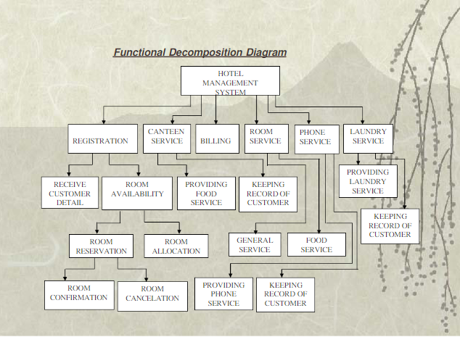

**DESCRIPTION OF EXISTING SYSTEM**

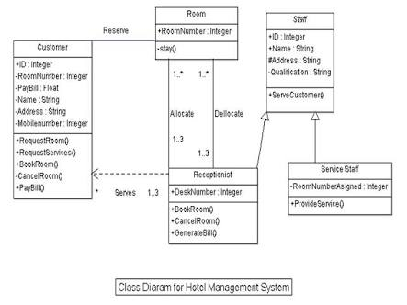

**USING SOFTWARE PROCESS MODEL**

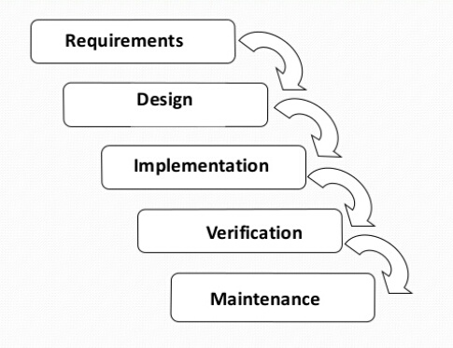

**DFD (Data flow diagram) of hotel management system**

**CONTEXT LEVEL DFD:**

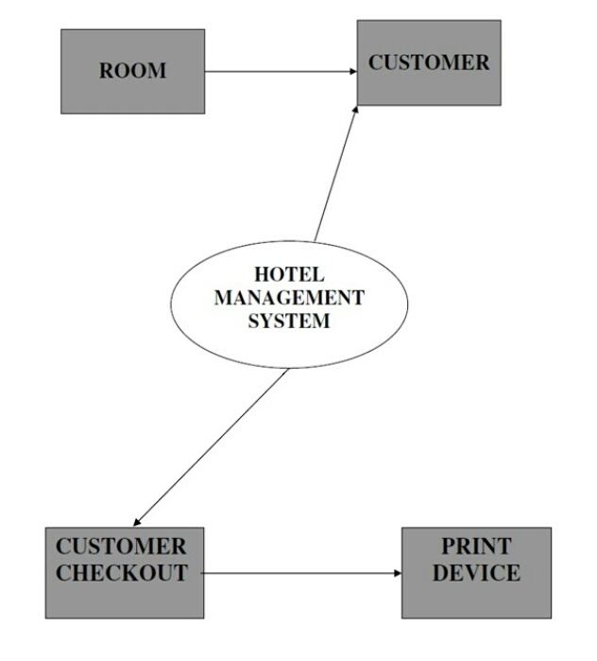

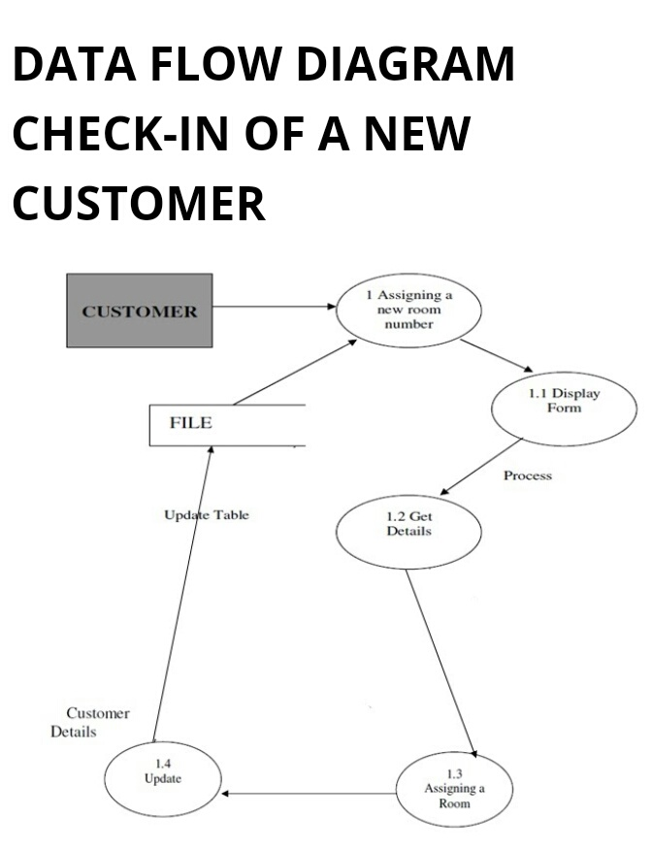

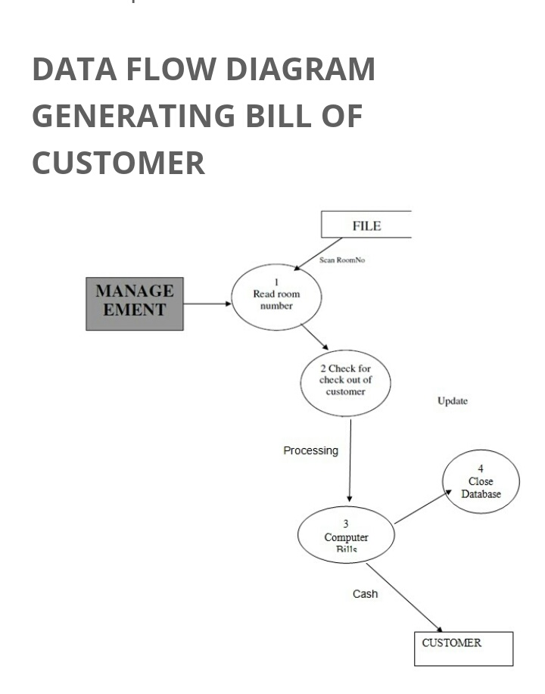

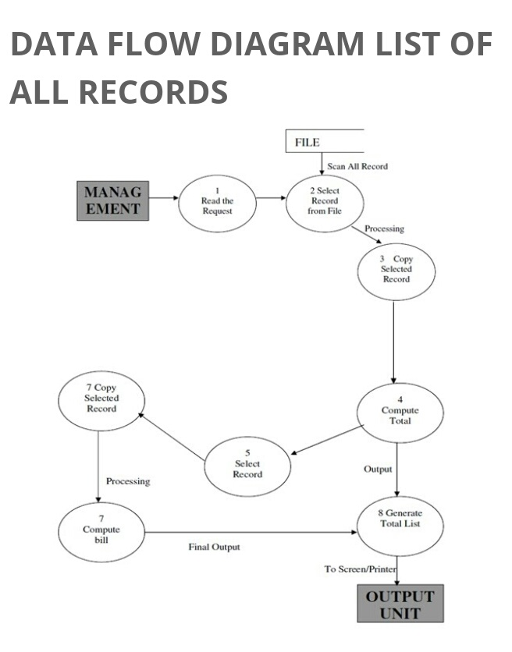

**CONCLUSION AND DRAWBACKS OF OUR PROJECT HOTEL MANAGEMENT SYSTEM:**

Our project is only a humble venture to satisfy the needs to manage the records. Several user-friendly coding has also been adopted. We have removed the hardships that were being faced by the existing system.

The proposed system has been made to reduce the time being spent on the existing system. The proposed system also helps in the detailed and smooth storage of the data and retrieval of the data.

With this system, cab arranging facilities and regulation of other tourism facilities for the customers will not be possible. The details of the trip can be directly chosen from the customer’s selected package, but the tourism facilities cannot undergo any modifications after selection.

The emergency facilities and services will not be made available online.

**FUTURE SCOPE OF THIS PROJECT**

With this proposed system, we can manage huge variation of data easily and thus helping us in carrying out the process of hotel management easily and effectively. Storage and modification of data can easily be done with this proposed system.

In future, the drawbacks of transport facilities arrangement and availability of emergency services and facilities online will be made possible. Also, more emphasis would be on making the code more efficient and compact for the future

**THANK YOU**